Project Overview
Nexus Dashboard is a production-deployed admin analytics platform built for the Malayalam AI Platform. It's a full-stack React application with a Supabase backend, auto-deployed to Vercel. As of 27 May 2026, it has completed 9 of 10 planned tasks across Phase 9 — its final hardening and deployment phase.

What's Been Built
The application covers 10 pages spanning a complete admin dashboard experience: live KPI tracking, analytics, order management, product catalog, user management, real-time notifications, and settings. The two most sensitive pages (Users and Settings) are properly gated behind role-based access control.

Technology Choices
The stack is modern and well-chosen for a small-to-medium SaaS dashboard:
- React 19 + Vite 8 — cutting-edge frontend tooling; React 19 is notably new as of the report date
- Tailwind CSS v4 — also very recent, meaning the team is tracking leading-edge releases
- Supabase on free tier (Nano) — handles auth, database, realtime, and row-level security in one platform; good cost-efficiency for early stage
- Vercel — sensible pairing with React/Vite, CI/CD is automatic

Strengths
1. Production readiness is genuine, not just declared. The report demonstrates real deployment artifacts: environment variables in both .env.local and Vercel, RLS policies on Supabase, a live URL, and auto-deploys wired up. This isn't a staging environment dressed up as production.
2. Security is layered correctly. Three separate access control mechanisms are in place: Supabase Auth session management, a ProtectedRoute component blocking unauthenticated access, and a RequireAdmin guard for elevated routes. RLS at the database level means the frontend can't be bypassed to access another user's profile data. Secrets are properly kept server-side.
3. Realtime is properly implemented. Using Supabase Realtime channel subscriptions (rather than polling) for notifications is the right architectural choice — it's event-driven, low-latency, and doesn't waste quota on a free-tier plan.
4. i18n is structurally sound. Malayalam support via react-i18next with localStorage persistence and lang attribute updates is thoughtful — it covers both user preference durability and accessibility/SEO semantics.
5. UX resilience is addressed. Error boundaries wrapping the entire app plus skeleton loading components for all major data-driven views (stat cards, tables, product cards, notifications) means users get graceful degradation instead of broken screens.

Weaknesses & Risks
1. Testing coverage is minimal. 4 unit tests covering only error boundaries and skeleton components is very thin for a production system. The 8 live data pages — orders, products, users, analytics — have zero test coverage. There are no integration tests and no E2E tests yet (Playwright is listed as a remaining action item). A bug in Supabase query logic or RBAC redirect behavior could ship undetected.
2. The custom domain is still unregistered. malayalamai.com isn't purchased yet, meaning the app is only accessible via a Vercel-generated URL (nexus-dashboard-liart.vercel.app). For a platform branded around "Malayalam AI," this is a visible gap — especially if the platform is being shared with end users.
3. No CI pipeline. GitHub Actions for running tests on push is listed as a remaining item. Currently, broken code could auto-deploy to production before anyone runs tests manually. Combined with thin test coverage, this represents a real deployment risk.
4. Free-tier Supabase constraints. The Nano plan has limits on database size, realtime connections, and bandwidth. As usage grows, the app could hit these silently. There's no mention of monitoring for Supabase quotas or a plan for upgrading.
5. Language switcher not yet wired to the UI. The i18n infrastructure is complete, but the LanguageSwitcher component isn't connected to the Settings page yet. Users can't actually change language from within the app — a disconnect between infrastructure and user-facing functionality.

Remaining Action Items — Prioritized
Priority | Item | Why
🔴 High | Add GitHub Actions CI | Prevents broken code from auto-deploying
🔴 High | Wire LanguageSwitcher into Settings | Completes the i18n feature end-to-end
🟡 Medium | Register malayalamai.com + add CNAME | Establishes branded production URL ($6.79)
🟡 Medium | Add Playwright E2E tests | Covers critical auth and RBAC flows
🟢 Low | Add Vercel env vars to GitHub Secrets | Required once CI is added

Overall Assessment
This is a well-structured, genuinely functional MVP that demonstrates solid engineering discipline — proper secrets management, database-level security, realtime subscriptions, accessibility considerations (WCAG 2.1 AA), and observable deployment. The Phase 9 framing suggests a methodical, phase-driven development approach.
The main vulnerability is the testing and CI gap — the infrastructure is live and auto-deploys, but the safety net for catching regressions isn't in place yet. That should be the first priority before the project scales in users or complexity.


You said: What is nex

686ad4c0-6b44-46e1-8be3-e4520b6b33fe-1779891153696_PROJ_PROG_REPORT_24 MAY 26.html
html
What is nex


Claude responded: Based on both your project reports, Nexus Dashboard is the admin control panel for your larger Malayalam AI Platform.
Ran a command
Ran a command
Based on both your project reports, Nexus Dashboard is the admin control panel for your larger Malayalam AI Platform. Here's how the two projects relate:

The Two Projects
1. Malayalam Voice AI (the core product) A full-stack SaaS application that transcribes and translates Malayalam speech to English (and back) using faster-Whisper. It has a FastAPI backend on Railway, a Next.js frontend on Vercel, Razorpay payment plans, and a streaming SSE pipeline. This is the main user-facing product.
2. Nexus Dashboard (the admin layer) A separate React + Supabase application built specifically to manage and monitor the Malayalam AI Platform. It gives you (the admin) visibility into orders, products, users, analytics, notifications, and settings — all pulling live data from Supabase with real-time updates.

In short
Nexus Dashboard is your internal operations hub — while end-users interact with malayalam-ai-frontend.vercel.app to transcribe audio, you use Nexus Dashboard at nexus-dashboard-liart.vercel.app to see what's happening across the platform: who's signing up, what orders are coming in, how the system is performing, and who has admin access.
Think of it as the backstage control room for the Malayalam AI product.


You said: start next?
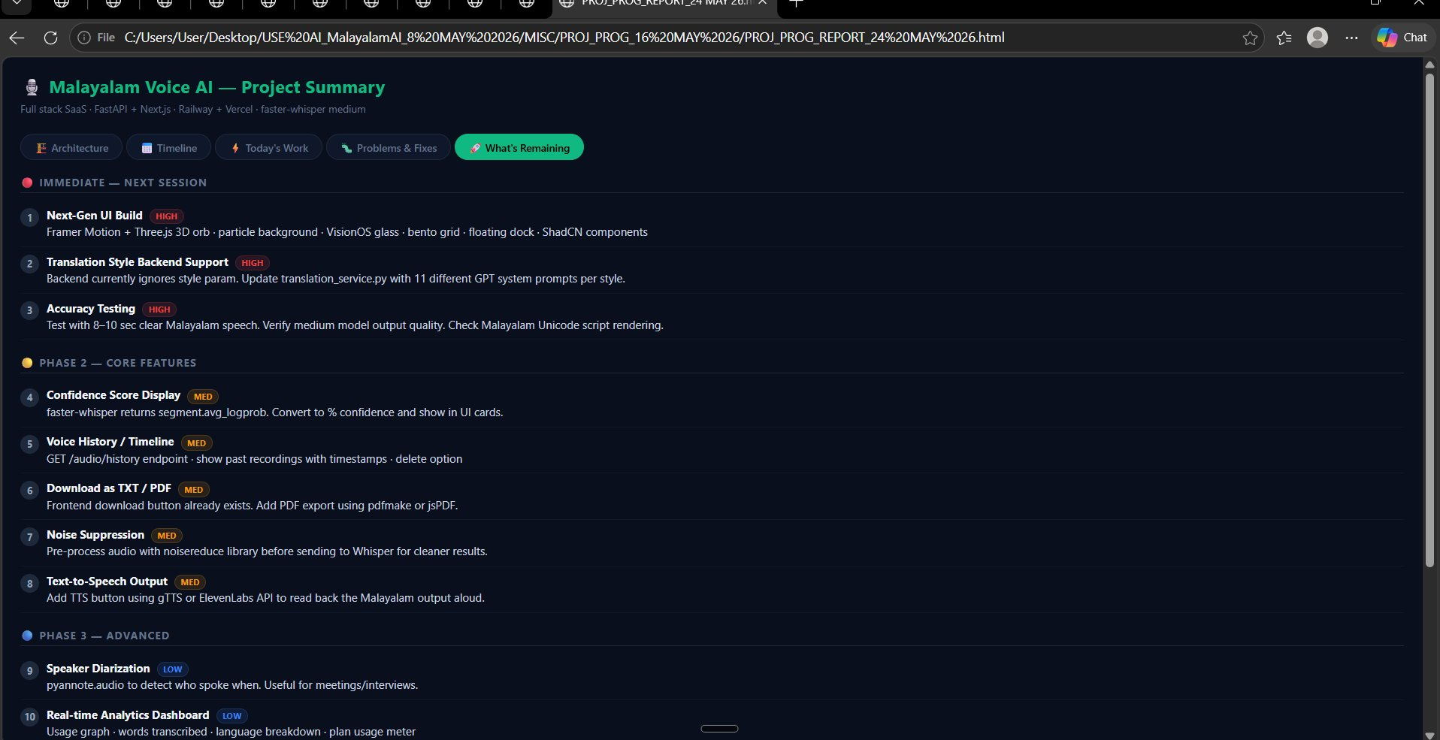Screenshot 2026-05-27 194332.png
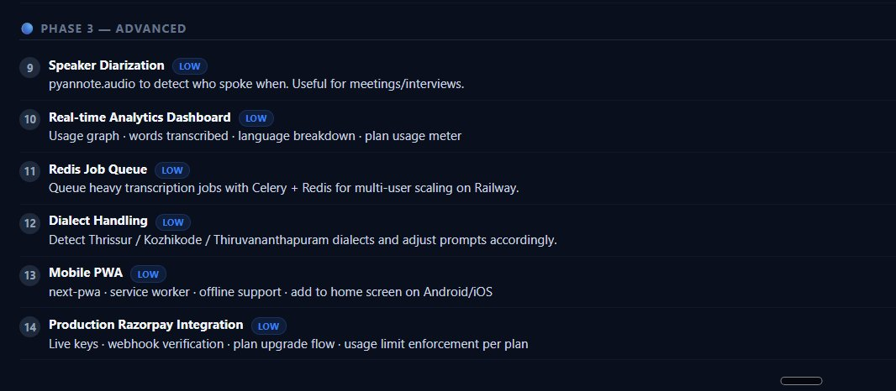Screenshot 2026-05-27 194337.png
start next?


Claude responded: Which task would you like to tackle first?
Thought process
Thought process
Which task would you like to tackle first?
- Next-Gen UI Build — the 3D orb + VisionOS glassmorphism UI (Framer Motion, Three.js, bento grid, floating dock)
- Translation Style Backend — wire up the 11 style chips to different GPT prompts in translation_service.py
- Accuracy Testing — systematic test run with clear Malayalam speech samples


You said: your choice, But brick by brick, one step at a time
your choice, But brick by brick, one step at a time


Claude responded: My choice: Translation Style Backend Support first.
Loaded tools
Loaded tools
My choice: Translation Style Backend Support first. It's the most contained brick — the 11 style chips already exist in the UI but the backend ignores them. One focused fix makes the whole feature real.
Used 6 tools
Used 6 tools
From the project reports, here's what we know about the current architecture:
- translation_service.py runs an optional GPT-3.5 refinement pass on the English translation output from Whisper
- The frontend sends a style param (one of 11 chips) but the backend currently ignores it — it uses a single hardcoded system prompt
- The function returns refined_text (fixed in a prior session from an empty-string bug)
- OPENAI_API_KEY is optional — if missing, the raw Whisper output is returned unchanged
- The endpoint is /audio/process (and /audio/process-stream)
Used 2 tools
Used 2 tools
Now defining the 11 styles. Based on the UI "tone selector" context for a Malayalam voice transcription tool, the most useful styles would be:
# | Key | Label | Purpose
1 | standard | Standard | Clean, accurate, neutral output
2 | formal | Formal | Official letters, documents
3 | casual | Casual | Everyday conversation
4 | news | News | Journalistic, third-person
5 | literary | Literary | Poetic, expressive prose
6 | business | Business | Corporate, professional
7 | academic | Academic | Technical, precise
8 | simple | Simple | Plain English, easy to read
9 | humorous | Humorous | Light, witty tone
10 | emotional | Emotional | Empathetic, heartfelt
11 | bullet | Bullet Points | Structured, scannable summary
Used 6 tools, created 2 files
Used 6 tools, created 2 files
Quick consistency check before presenting:
- ✅ DEFAULT_STYLE = "standard" defined once in translation_service.py, imported into audio.py — no duplication
- ✅ Both endpoints (/process and /process-stream) accept style as a Form field with the same default
- ✅ OPENAI_API_KEY guard still in place — returns raw text gracefully if key is missing
- ✅ Unknown style keys fall back to standard with a warning log — no crashes
- ✅ Response includes "style": resolved_style so the frontend can confirm what was applied
- ✅ available_styles() returned in the blocking response — useful for frontend validation
- ✅ refined_text field name preserved — matches the frontend fix from a prior session
Read a file, used a tool
Read a file, used a tool
Brick 1 done. Here's what was built:
translation_service.py — drop the whole file into your backend. The 11 style prompts live in a STYLE_PROMPTS dict keyed by style name. The refine_translation(raw_text, style) function picks the right prompt, calls GPT-3.5, and falls back gracefully if the API key is missing or the call fails.
audio.py — both /audio/process and /audio/process-stream now accept style as a form field. It flows straight through to the refinement step.
To deploy: copy both files into your Railway backend repo, then git push origin main. No schema changes, no new dependencies.

Next brick when you're ready: the frontend style chips need to send the style value in the FormData. Right now they likely just display the selection visually. Want to tackle that — the page.js change to wire the chip selection into the API call?
C:\Users\User\AppData\Roaming\Claude\local-agent-mode-sessions\881382c2-4d92-4634-959b-5feb71a9ca45\970857d9-fe7a-41d7-bb57-013cafc2b0fd\local_50e84b68-5079-4ae1-94b1-1c7d9a86e90d\outputs\translation_service.py

Show in Folder

C:\Users\User\AppData\Roaming\Claude\local-agent-mode-sessions\881382c2-4d92-4634-959b-5feb71a9ca45\970857d9-fe7a-41d7-bb57-013cafc2b0fd\local_50e84b68-5079-4ae1-94b1-1c7d9a86e90d\outputs\audio.py

Show in Folder



You said: translation_service.
translation_service.py — drop the whole file into your backend, cmd pl


Claude responded: Run this in PowerShell — replace the destination path with wherever your backend repo lives on your machine:
Thought process
Thought process
Run this in PowerShell — replace the destination path with wherever your backend repo lives on your machine:
powershell
Copy-Item "C:\Users\User\AppData\Roaming\Claude\local-agent-mode-sessions\881382c2-4d92-4634-959b-5feb71a9ca45\970857d9-fe7a-41d7-bb57-013cafc2b0fd\local_50e84b68-5079-4ae1-94b1-1c7d9a86e90d\outputs\translation_service.py" -Destination "C:\path\to\your\backend\translation_service.py" -Force
Then push to Railway:
powershell
cd C:\path\to\your\backend
git add translation_service.py
git commit -m "feat: 11 translation styles with GPT system prompts"
git push origin main

What's the path to your backend folder? I can give you the exact command with no placeholders.


You said: 2 files saved
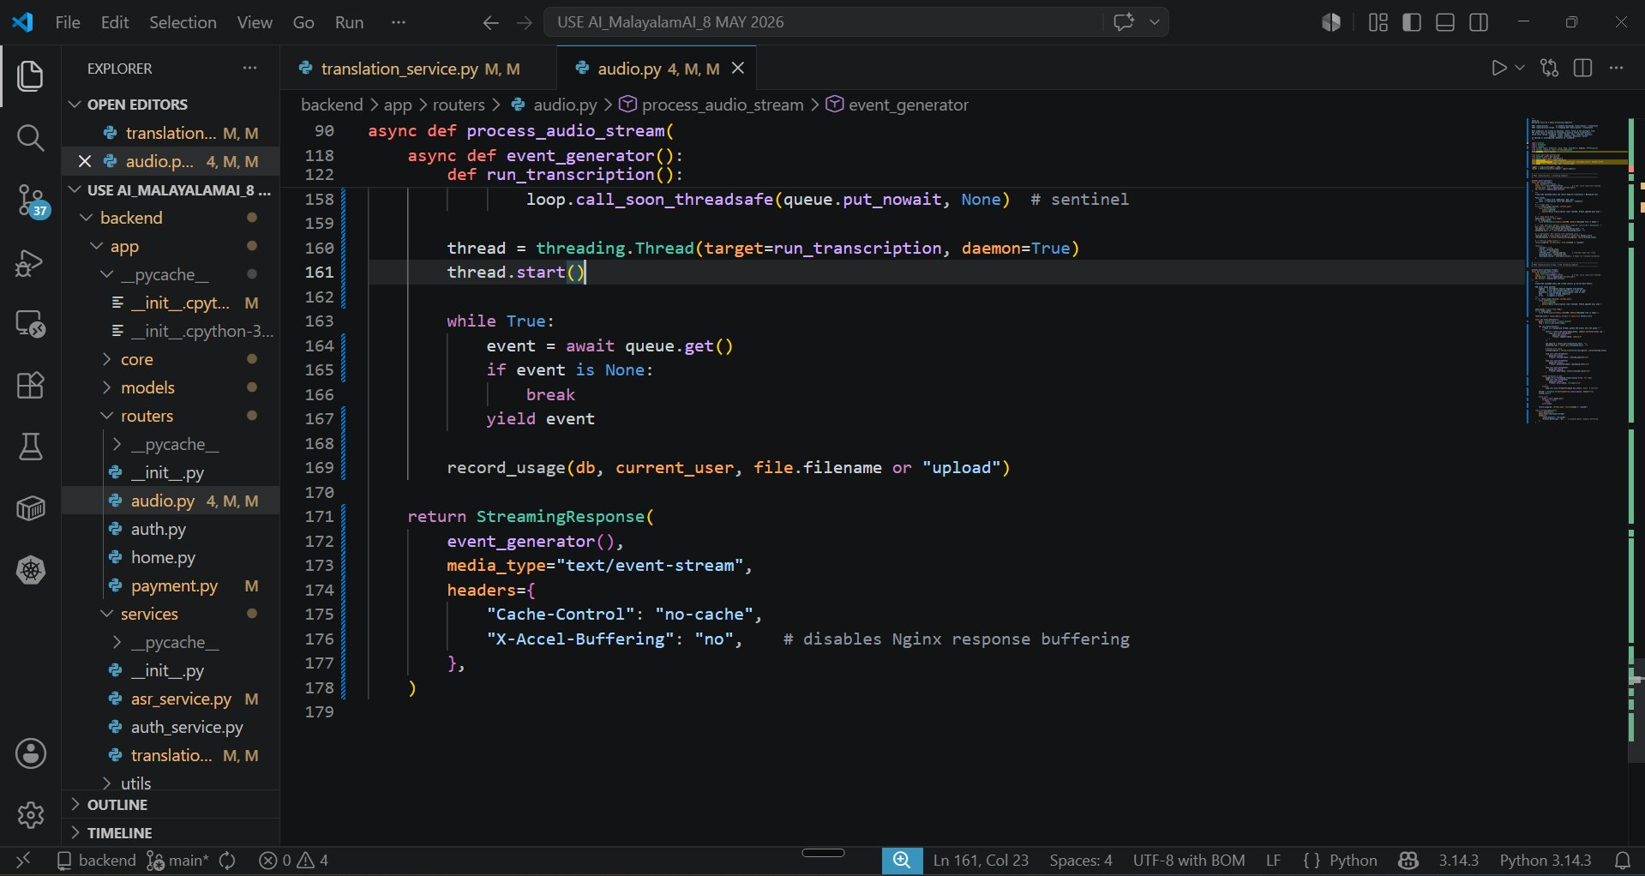Screenshot 2026-05-27 195527.png
2 files saved


Claude responded: Both files are in the right place.
Thought process
Thought process
Both files are in the right place. Now push to Railway:
powershell
cd "C:\Users\User\Desktop\USE AI_MalayalamAI_8 MAY 2026\backend"
git add app/routers/audio.py services/translation_service.py
git commit -m "feat: 11 translation styles wired through pipeline"
git push origin main
Railway will auto-deploy on the push. Once it's live, the 11 style chips will actually do something different — ready for the next brick whenever you are.


You said: > git push origin main
git push origin main fatal: pathspec 'services/translation_service.py' did not match any files On branch main Your branch is up to date with 'origin/main'. Changes not staged for commit: (use "git add <file>..." to update what will be committed) (use "git restore <file>..." to discard changes in working directory) modified: app/routers/audio.py modified: app/services/translation_service.py modified: nixpacks.toml modified: requirements.txt Untracked files: (use "git add <file>..." to include in what will be committed) fix_api_url.py fix_audio.py fix_db.py fix_restore.py fix_startup.py fix_startup2.py write_audio.py no changes added to commit (use "git add" and/or "git commit -a") Everything up-to-date PS C:\Users\User\Desktop\USE AI_MalayalamAI_8 MAY 2026\backend>
Show more


Claude responded: It's in app/services/ not services/.
Thought process
Thought process
It's in app/services/ not services/. Correct command:
powershell
git add app/routers/audio.py app/services/translation_service.py
git commit -m "feat: 11 translation styles wired through pipeline"
git push origin main


You said: Everything up-to-date
Everything up-to-date PS C:\Users\User\Desktop\USE AI_MalayalamAI_8 MAY 2026\backend> git add app/routers/audio.py app/services/translation_service.py >> git commit -m "feat: 11 translation styles wired through pipeline" >> git push origin main warning: in the working copy of 'app/routers/audio.py', LF will be replaced by CRLF the next time Git touches it warning: in the working copy of 'app/services/translation_service.py', LF will be replaced by CRLF the next time Git touches it [main b238222] feat: 11 translation styles wired through pipeline 2 files changed, 317 insertions(+), 169 deletions(-) Enumerating objects: 13, done. Counting objects: 100% (13/13), done. Delta compression using up to 12 threads Compressing objects: 100% (7/7), done. Writing objects: 100% (7/7), 4.53 KiB | 2.26 MiB/s, done. Total 7 (delta 4), reused 0 (delta 0), pack-reused 0 (from 0) remote: Resolving deltas: 100% (4/4), completed with 4 local objects. To https://github.com/mamcbt-ai/USE-AI-MalayalamAI.git 371fb09..b238222 main -> main PS C:\Users\User\Desktop\USE AI_MalayalamAI_8 MAY 2026\backend>
Show more


Claude responded: Pushed.
Thought process
Thought process
Pushed. Commit b238222 is live on GitHub — Railway is deploying now.
The LF/CRLF warnings are harmless on Windows, nothing to worry about.
What just shipped:
- 11 style prompts active in translation_service.py
- Both /audio/process and /audio/process-stream now accept and pass the style field
Next brick: the frontend — page.js needs to send the selected style chip value in the FormData when it calls the API. Right now the chips are decorative. Want to do that now?


You said: provide a project progress report yet and what's remaining.
provide a project progress report yet and what's remaining. Explain step by step


Claude responded: Here's the full picture across both projects.
Thought process
Thought process
Here's the full picture across both projects.

Project 1: Malayalam Voice AI

What's Done — Step by Step
Step 1 — Backend Foundation FastAPI server set up on Railway. faster-whisper (small model at the time), SQLite database, JWT authentication, and the first working /audio/process endpoint. The app was live on Railway.
Step 2 — Frontend Foundation Next.js app deployed to Vercel. Basic MediaRecorder UI that captured audio and uploaded it to the backend. Results displayed on screen. End-to-end flow working for the first time.
Step 3 — Bug Fix: Empty output boxes Both the English and Malayalam output boxes were showing "–". Two separate bugs: the frontend was reading the wrong field name (result.translation_output?.translation instead of result.refined_text), and the backend was only running one Whisper pass so Malayalam was never generated. Both fixed.
Step 4 — Accuracy upgrade Switched from Whisper small to medium model. Added a second Whisper pass (task=transcribe) to generate Malayalam Unicode output alongside the English translation. Removed initial_prompt which was causing hallucinations ("RAAAAR", "And", "The"). Added Silero VAD with vad_filter=True to ignore silence.
Step 5 — Streaming Added /audio/process-stream endpoint using threading.Thread + asyncio.Queue bridge. Text now appears word by word in the UI via Server-Sent Events instead of waiting for the full result.
Step 6 — Infrastructure fixes Three Railway/Vercel deployment bugs resolved: Railway root directory misconfigured, Vercel watching wrong branch, Railway watching master instead of main. Usage limit bug fixed — was counting all users' records instead of filtering by the current user.
Step 7 — Glassmorphism UI deployed Complete 548-line page.js rewrite: glassmorphism design, waveform canvas, 11 style chips, copy buttons, dark/light mode toggle, file upload, Razorpay upgrade modal. Live on Vercel.
Step 8 — Translation Style Backend (today) translation_service.py updated with 11 individual GPT-3.5 system prompts — one per style chip. audio.py updated to accept and pass the style field through the entire pipeline. Committed b238222, deployed to Railway.

What's Remaining — In Priority Order
Immediate (HIGH)
- Wire style chips to the API — the frontend chips are still decorative. page.js needs to capture the selected chip and include style in the FormData on upload. One small change, completes the feature end-to-end.
- Next-Gen UI Build — the 200+ line spec you provided: Framer Motion animations, Three.js 3D orb, particle background, VisionOS glassmorphism panels, bento grid layout, floating dock, ShadCN components. This is a full page.js rewrite.
- Accuracy Testing — systematic test with 8–10 seconds of clear Malayalam speech. Verify the medium model output quality, check each of the 11 style outputs, confirm Malayalam Unicode script renders correctly in the browser.
Phase 2 — Core Features (MEDIUM)
- Confidence Score — faster-whisper returns segment.avg_logprob. Convert to a percentage and show it as a confidence indicator on the output card.
- Voice History / Timeline — GET /audio/history endpoint returning past recordings with timestamps. Frontend shows a scrollable history panel with delete option.
- Download as TXT / PDF — the download button already exists in the UI. Wire it up with jsPDF or pdfmake on the frontend. No backend change needed.
- Noise Suppression — pre-process audio with the noisereduce Python library before passing to Whisper. Improves accuracy on noisy recordings.
- Text-to-Speech — a "Listen" button that reads the Malayalam output back aloud using gTTS or ElevenLabs API.
Phase 3 — Advanced (LOW)
- Speaker Diarization — pyannote.audio to detect who spoke when. Useful for meetings.
- Real-time Analytics Dashboard — usage graphs, words transcribed, plan usage meter.
- Redis Job Queue — Celery + Redis for handling multiple concurrent users on Railway.
- Dialect Handling — detect Thrissur / Kozhikode / Thiruvananthapuram dialects and adjust prompts.
- Mobile PWA — next-pwa, service worker, offline support, add to home screen.
- Production Razorpay — live keys, webhook verification, plan enforcement per tier.

Project 2: Nexus Dashboard

What's Done
All 9 of 10 Phase 9 tasks complete. The dashboard is live at nexus-dashboard-liart.vercel.app with Supabase data, role-based access control, real-time notifications, 4 passing unit tests, Malayalam i18n infrastructure, and Vercel Analytics.

What's Remaining
- Register malayalamai.com — $6.79/yr on Namecheap. The custom domain dashboard.malayalamai.com is configured in Vercel but can't resolve until the domain exists.
- Add CNAME record — once purchased, add Host: dashboard, Value: aa16a456eed4c77b.vercel-dns-017.com. SSL auto-provisions via Let's Encrypt.
- Wire LanguageSwitcher to Settings UI — the i18n backend is complete (en.json, ml.json, localStorage persistence) but the LanguageSwitcher.jsx component isn't imported into the Settings Appearance tab yet. One import + one JSX line.
- GitHub Actions CI — add .github/workflows/ci.yml to run the 4 unit tests on every push. Prevents broken code from auto-deploying to production.
- Playwright E2E tests — npm init playwright@latest, write tests/e2e/nexus.spec.js covering login, RBAC redirect, and real-time notification flow.
- Add Vercel env vars to GitHub Secrets — needed once CI is running so the test pipeline can access VITE_SUPABASE_URL and VITE_SUPABASE_PUBLISHABLE_KEY.

Summary
Project | Done | Remaining
Malayalam Voice AI | 8 steps shipped | 14 items across 3 phases
Nexus Dashboard | 9/10 tasks | 6 items, mostly polish + CI
The single highest-value next brick across both projects is wiring the style chips to the API in page.js — it's a 10-minute change that completes the feature you just deployed to Railway.

